**Experiment No. 4**

**Title :** Implementation of Queue Linear Data Structure

**Problem Statement :** Implementing linear data structure queue using array with functions

Enqueue()

Dequeue()

Display()

**Algorithm :**

**S1 :** Start

**S2 :** Declare an array of some size, front and rear variables to keep a track of the index of stack.

**S3 :** Call the functions in switch statements.

**S4 :** In enqueue function check if front=-1 if yes make front=0 and increment the rear value and with that as index put the value in queue array.

**S5 :** In dequeue function check if front =-1 or greater than rear value if so queue is empty else remove the element at index equal to front.

**S6 :** In display function we display the queue from front to rear.

**S7 :** Stop

**Code :**

#include<stdio.h>

# define MAX 5

int front = -1;

int rear = -1;

int queue[];

void enqueue()

{

int var;

if(front==-1)

front = 0;

// if(rear >= MAX - 1)

// {

// printf("Queue is FULL\n");

// return;

// }

printf("Enter the value :");

scanf("%d",&var);

rear = rear + 1;

queue[rear] = var;

printf("%d is queued\n",queue[rear]);

}

void dequeue()

{

if(front== -1 || front > rear)

{

printf("Queue is EMPTY\n");

return;

}

printf("%d is dequeued\n",queue[front]);

front = front + 1;

}

void display()

{

int i;

for(i=front;i<=rear;i++)

{

printf("%d\t",queue[i]);

}

printf("\n");

}

int main()

{

int ch;

start :

printf("Enter the choice\n1.Enqueue\t2.Dequeue\t3.Display\t");

scanf("%d",&ch);

switch(ch)

{

case 1 :

enqueue();

break;

case 2 :

dequeue();

break;

case 3 :

display();

break;

default :

printf("Enter the correct choice\n");

}

goto start

**Output :**

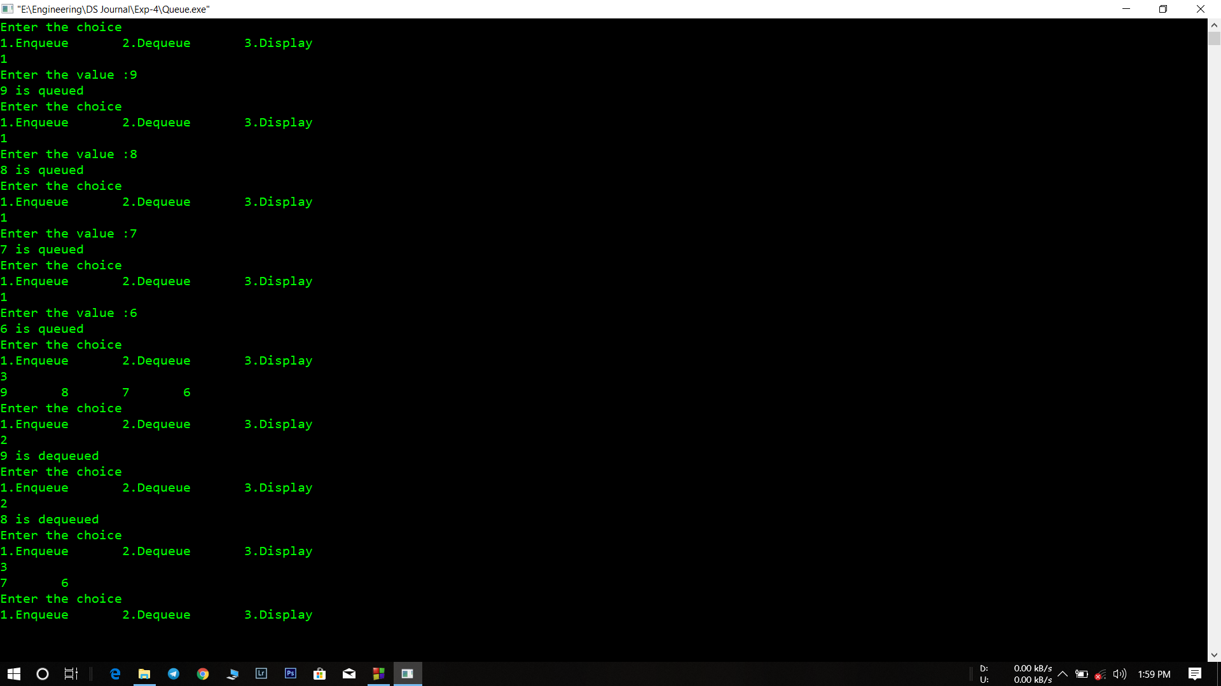

**Analysis :**

* Queue size is limited which makes number of operations limited.
* If queue is once full and if we dequeue all the values and then try to enqueue again it leads to an error since queue size is limited.
* If the front and rear value gets compromised the queue gives an error since they are the only values that control the operation of queue.